CM Explorer Installation and Configuration

# Purpose

This document describes how to install and Configure ODBC drivers, ODBC connection and CM Explorer feature.

# General Prerequisites

* The user of this document must be familiar with administering the Windows Server 2012 operating system.
* The user of the document must be familiar with the use of PowerShell command-line interface (CLI) on the Windows 2012 Server.
* The user must be familiar with the Network Analytics Server platform and its components.

# Installation Prerequisites

* The Network Analytics Server platform must be installed.
* The CM Explorer package (network-analytics-cm-explorer<R-State>.zip must be placed on the Network Analytics Server in C:\temp\media\netanserver.
* Extract the package into the C:\temp\media\netanserver.

# Installation of ODBC driver

On Network Analytics server, launch a PowerShell console (not PowerShell ISE) as Administrator and Run following command.

1.

PS C:\Users\Administrator> **cd C:\temp\media\netanserver\network-analytics-cm-explorer-<R-State>\ODBC\common**

PS C:\temp\media\netanserver\network-analytics-cm-explorer-<R-State>\ODBC\common > **.\setup.exe LAX_VM**

**"C:\Ericsson\NetAnServer\Server\7.11\jdk\bin\java.exe" -f .\installer.properties -i silent**

2.

PS C:\temp\media\netanserver\network-analytics-cm-explorer-<R-State>\ODBC\common >

**cd ..\odbc**

PS C:\temp\media\netanserver\network-analytics-cm-explorer-<R-State>\ODBC\odbc> **.\setup.exe LAX_VM "C:\Ericsson\NetAnServer\Server\7.11\jdk\bin\java.exe" -f .\installer.properties -i silent**

# Configure Data Source

Launch a PowerShell console (not PowerShell ISE) as Administrator and

Run following command.

1.

PS C:\Users\Administrator> **C:\Windows\system32\odbcad32.exe**

2.

In the **ODBC Data Sources (64-bit)** dialog,

In **System DSN** tab, Click on **Add** button

Select **Sybase IQ**

Click on **Finish** button.

Figure 1

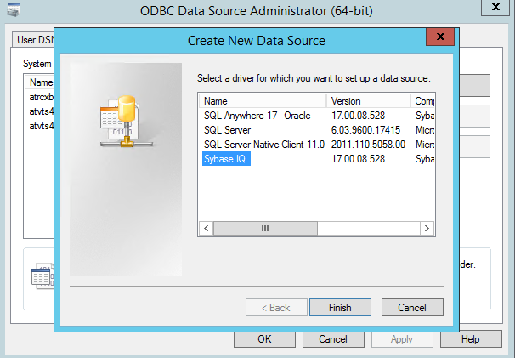

Step 3:

In **ODBC Configuration for SQL Anywhere** dialog,

In **ODBC** tab

Click **Data source name** textbox,

*<Input the data source name E.g.: ENIQ server name>*

Figure 2

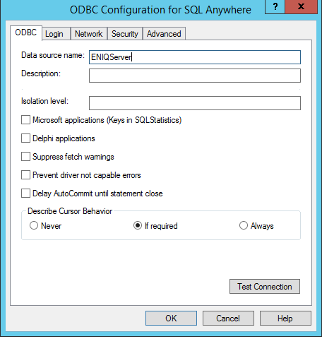

Step 4:

Click on **Login** Tab

Select *Database* from **Authentication** dropdown

Click on **User ID** text box,

<Input the dc user name: dc>

Click on **Password** text box,

<Input the dc password: E.g.: dc>

Select *None* from **Encode password** dropdown,

Select *Connect to a running database on another computer from* **Action** dropdown.

Click on **Server name** text box

*<Input the Server name E.g.: dwh_reader_2 or dwhdb >*

**Note:** dwh_reader2 in the case of multiblade server deployment.

dwhdb in the case of single blade or rack server deployment >

Click on **Database name** textbox

<Input the Database name: dwhdb>

Figure 3

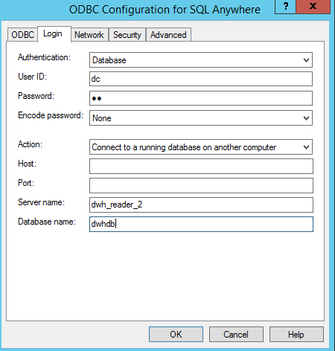

Click on **Network** tab

Select *NONE* from DoBroadcast

Click on **Host**

<Input the FQDN of ENIQ server: E.g.: eniq_cs.aem.test.ie >

**Note:** ENIQ Reader 2 FQDN in the case of multiblade server deployment.

ENIQ Co Ordinator FQDN in the case of single blade or rack server deployment

Click on **Port**

<Input the dhwdb database port number of ENIQ Eg: 2640 or 2642>

**Note:** 2642in the case of multiblade server deployment.

2640 in the case of single blade or rack server deployment.

Figure 4

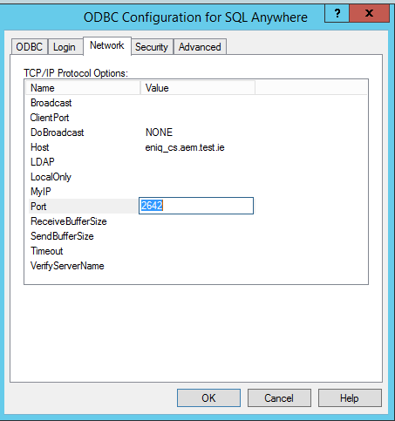

Click on **ODBC** tab and click on **Test Connection** button.

Connection successful dialog should appear like below:

Figure 5

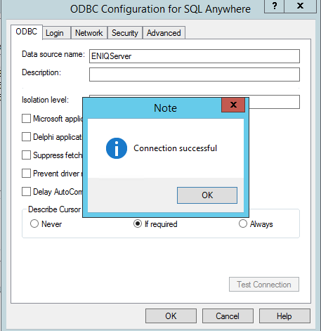

Click **OK** button.

Click **OK** button.

Click **OK** button.

# Save CM Explorer dxp in Network Analytics Server Library

1.Launch Network Analytics Analyst as Administrator user.

2.Click on **File** -> **Open**

3.Browse to the CMExplorer.dxp file location (C:\temp\media\netanserver\network-analytics-cm-explorer-<R-State>\Analysis) and select it

4.Click on **OK** button

5.Once the file is opened, Click on **File**-**>Save as ->Library item …**

6.Create a Folder (E.g.: CMExplorer) under Custom Library.

7.Click on **Finish** button